Social Media Kit
Parenting in the time of COVID-19

The coronavirus disease (COVID-19) pandemic has upended family life around the world. School closures, working remote, physical distancing — it's a lot to navigate for anyone, but especially for parents. A group of partners teamed up with the Parenting for Lifelong Health initiative to bring parents and caregivers a set of handy tips to help manage this new (temporary) normal.

Note: These messages can be adapted for various social media platforms including Instagram, Facebook, Twitter, WhatsApp, Viber, etc; tags can also be adapted to fit your target audience as long as the images remain constant with reference to further information either on the WHO, UNICEF, or Parenting for Lifelong Health COVID-19 websites.

Tag us: Facebook @COVID19Parenting Instagram @COVID19Parenting Twitter @ParentingC19
Tag partners: @WHO @UNICEF @USAID @CDCgov @ParentingLH @GPtoEndViolence @accelerate_hub
Hashtags: #COVID19Parenting #COVID19
Websites:
- Resources in over 100 languages www.covid19parenting.com
- UNICEF link here
- WHO link here
Link to evidence base: here

Visual | Message for Twitter/Facebook/Instagram
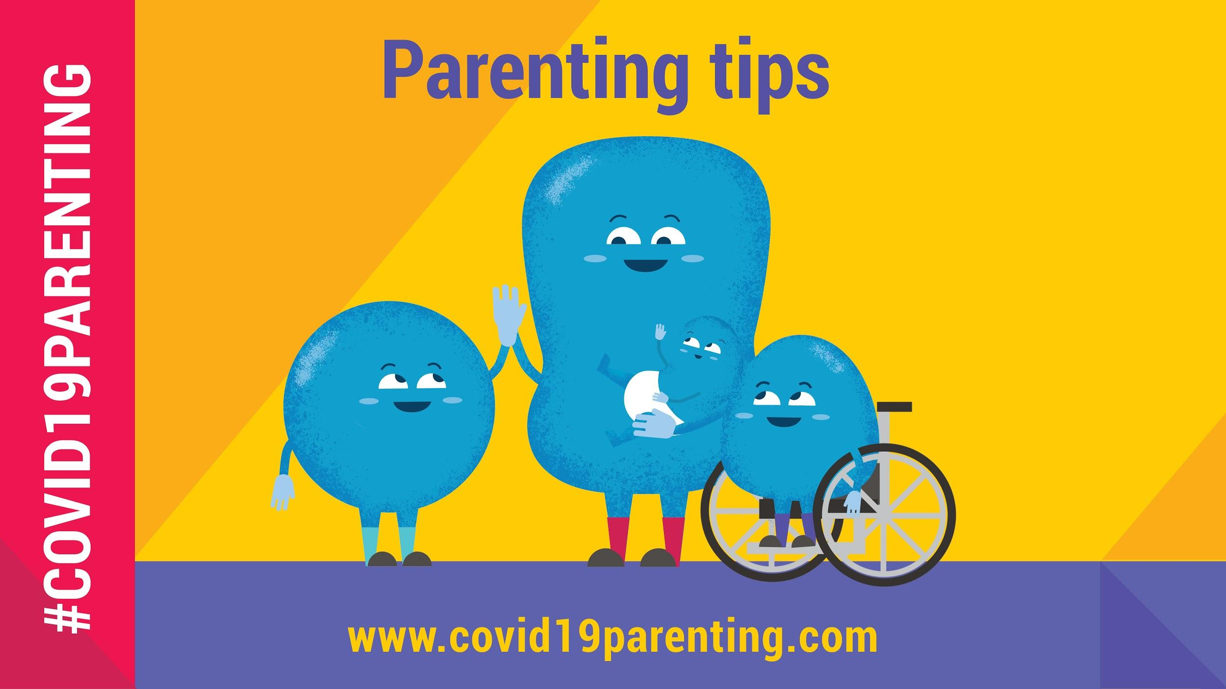 | These parenting tips will help you stay safe, happy & healthy during #COVID19 & beyond:  #COVID19Parenting covid19parenting.com  ✅ Keep it positive  ✅ Make daily routines  ✅ Spend time one-on-one  ✅ Manage stress  ✅ Talk about COVID19
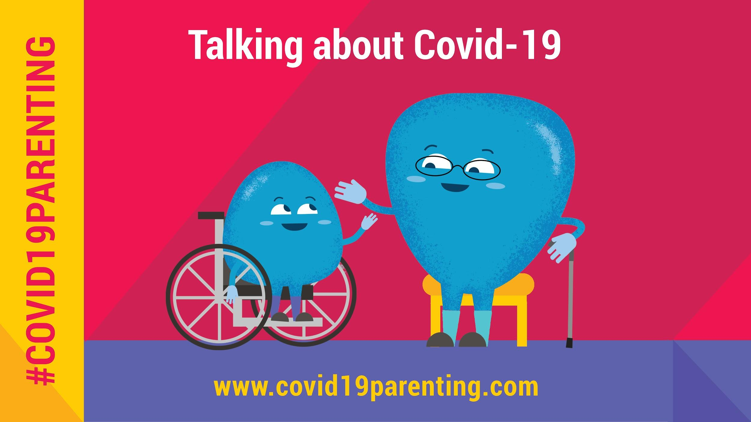 | Talk to your child about #COVID19.  They will already have heard something. Silence and secrets do not protect our children. Honesty and openness do. Think about how much they will understand. You know them best.  #COVID19Parenting tips: covid19parenting.com
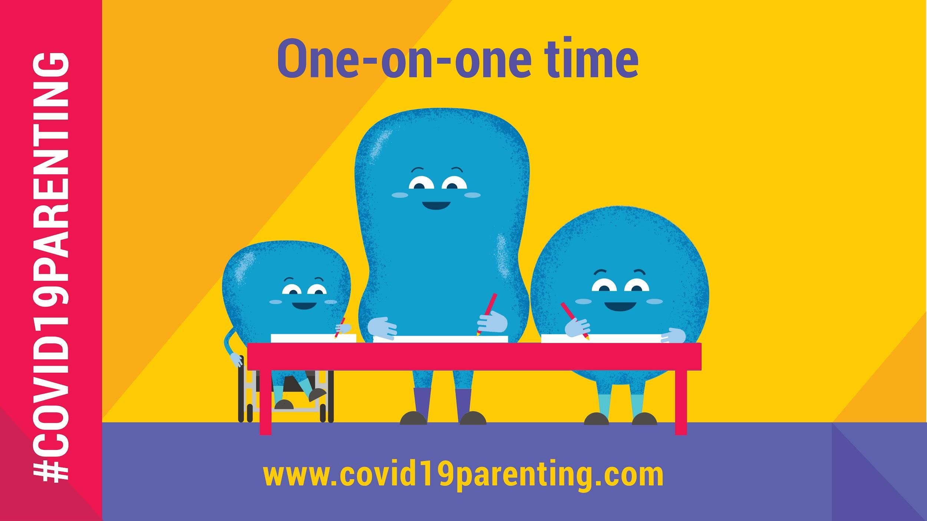 | Spend one-on-one time with your kids!  School shutdown is also a chance to make better relationships with our children. One-on-One time is free & fun: draw, dance and no phone or TV. It will help them feel safe and loved.  #COVID19Parenting tips: covid19parenting.com
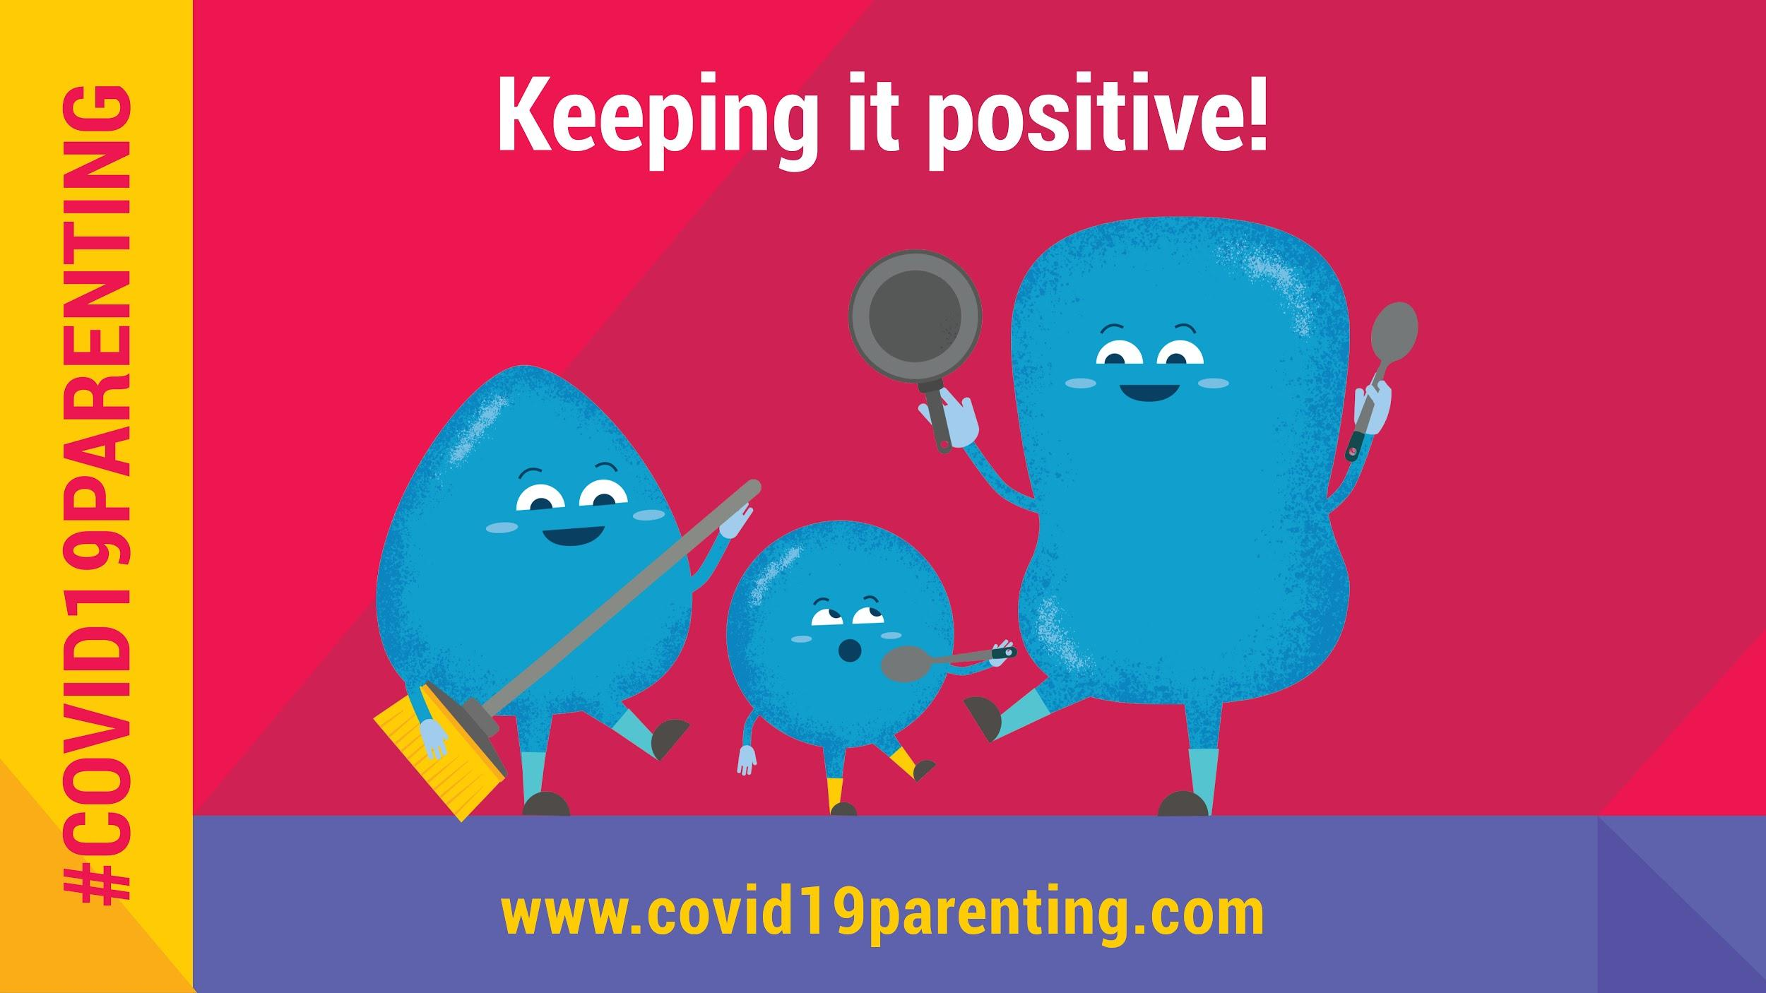 | Keep it positive!  It's hard to feel positive when our kids are driving us crazy. We often end up saying “Stop doing that!” But they will listen better to your positive instructions & praise for what they do right.  #COVID19Parenting tips: covid19parenting.com
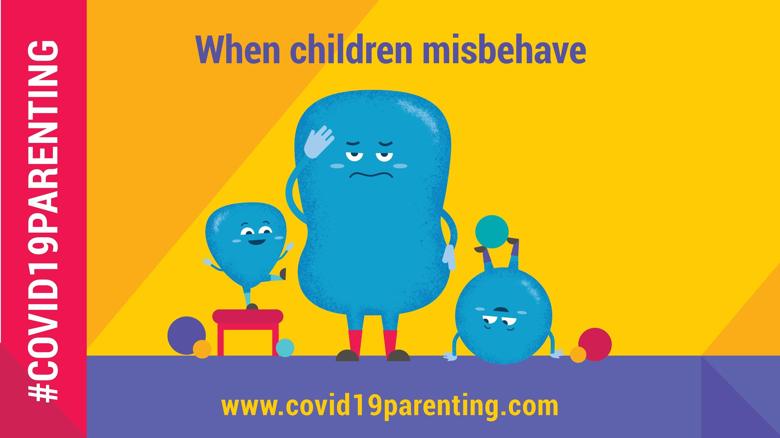 | Kids at home driving you crazy?  Feeling like you are going to scream? All children misbehave - it is normal. Catching bad behaviour early can help. Try to redirect them to a positive behaviour. Prevent, protect, and praise!  #COVID19Parenting tips: covid19parenting.com
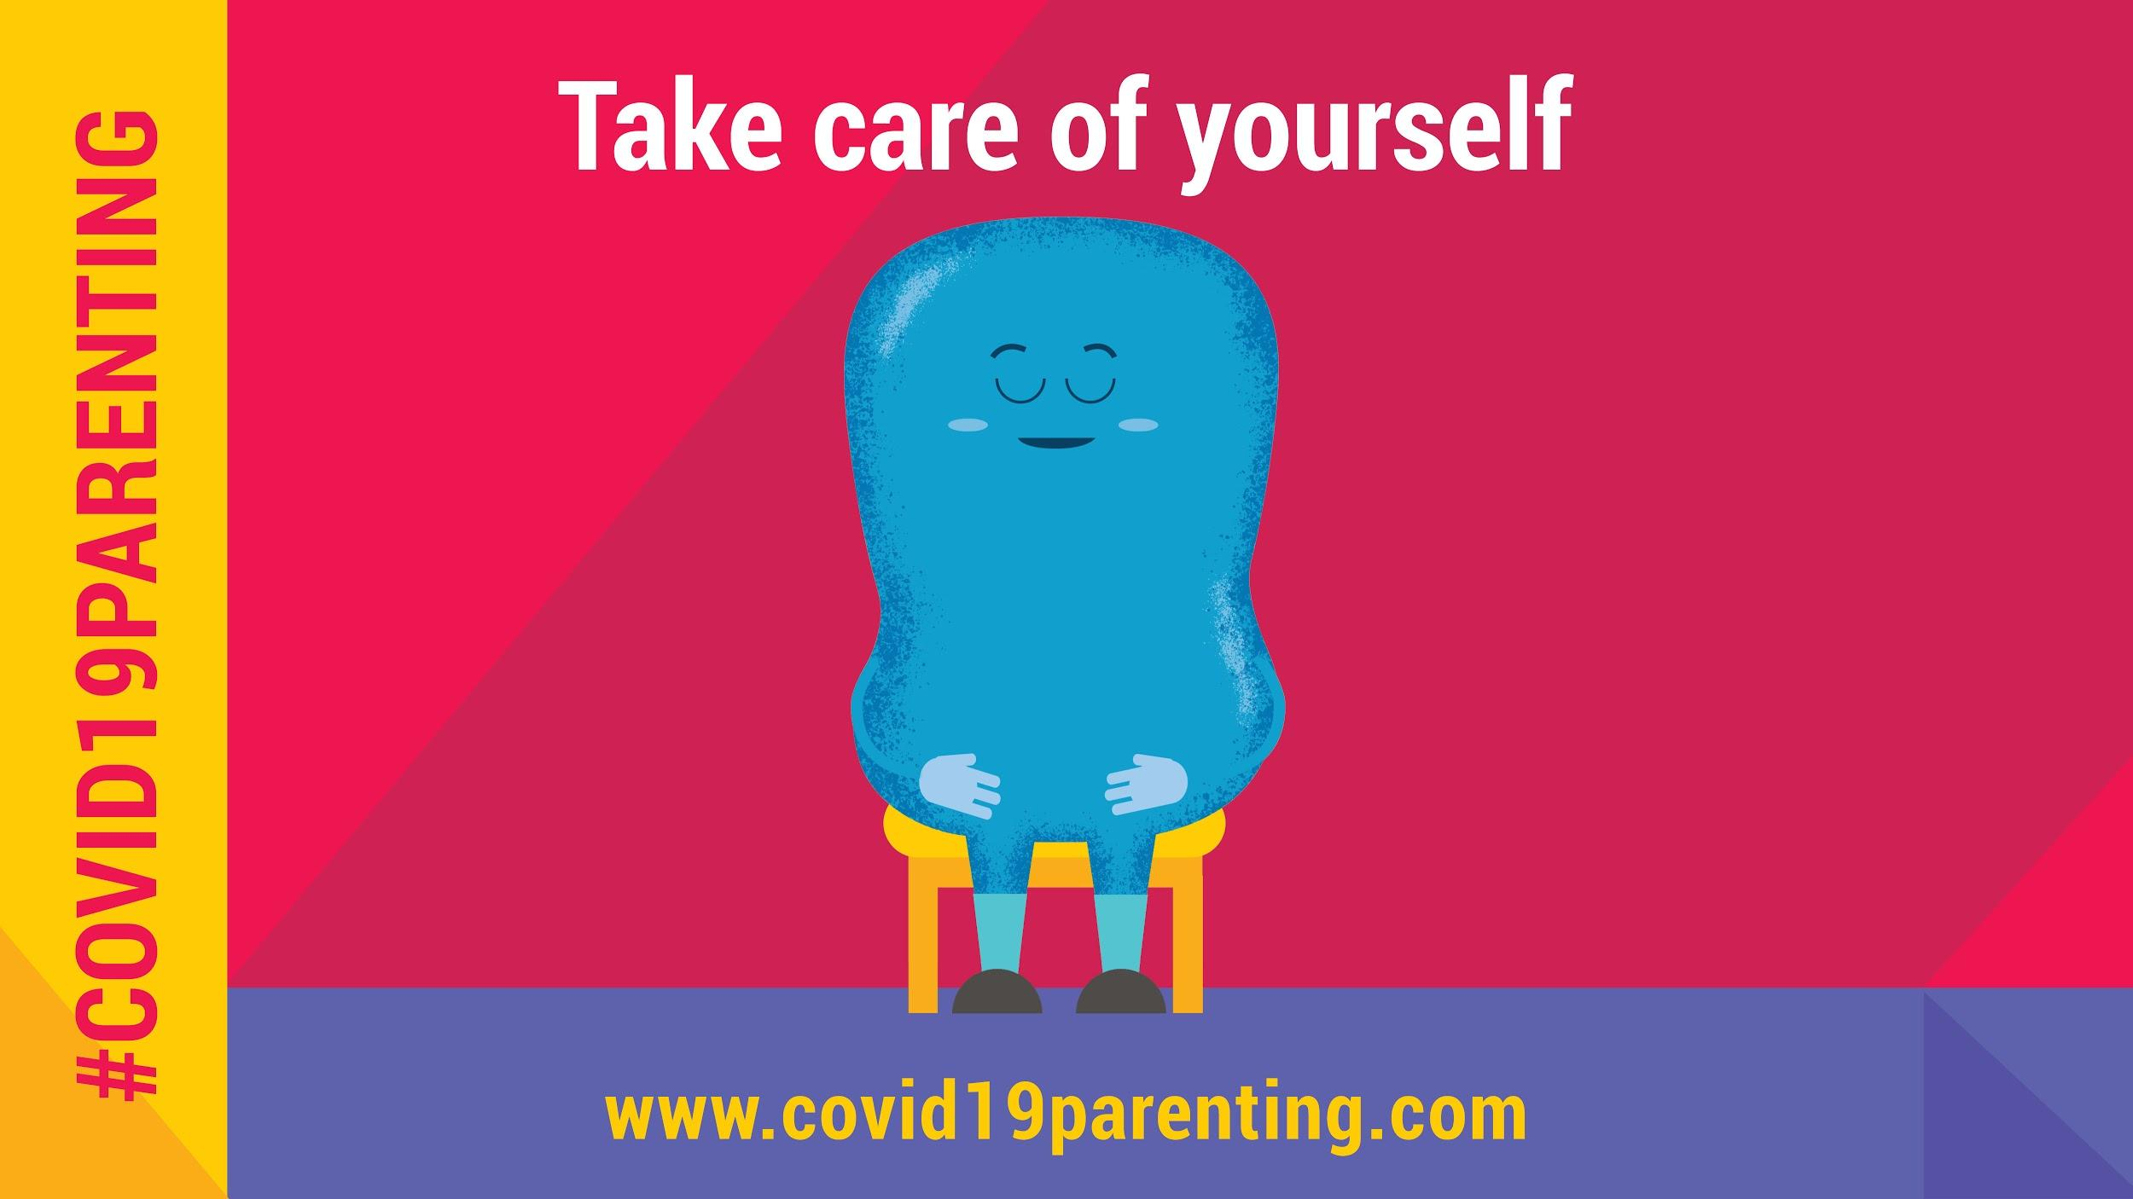 | Keep calm & manage stress.  Crowded house? Stressed out? #COVID19 is a stressful time. Share your feelings. Take a break. Take care of yourself so you can take care of your children. You can do it!  #COVID19Parenting tips: covid19parenting.com
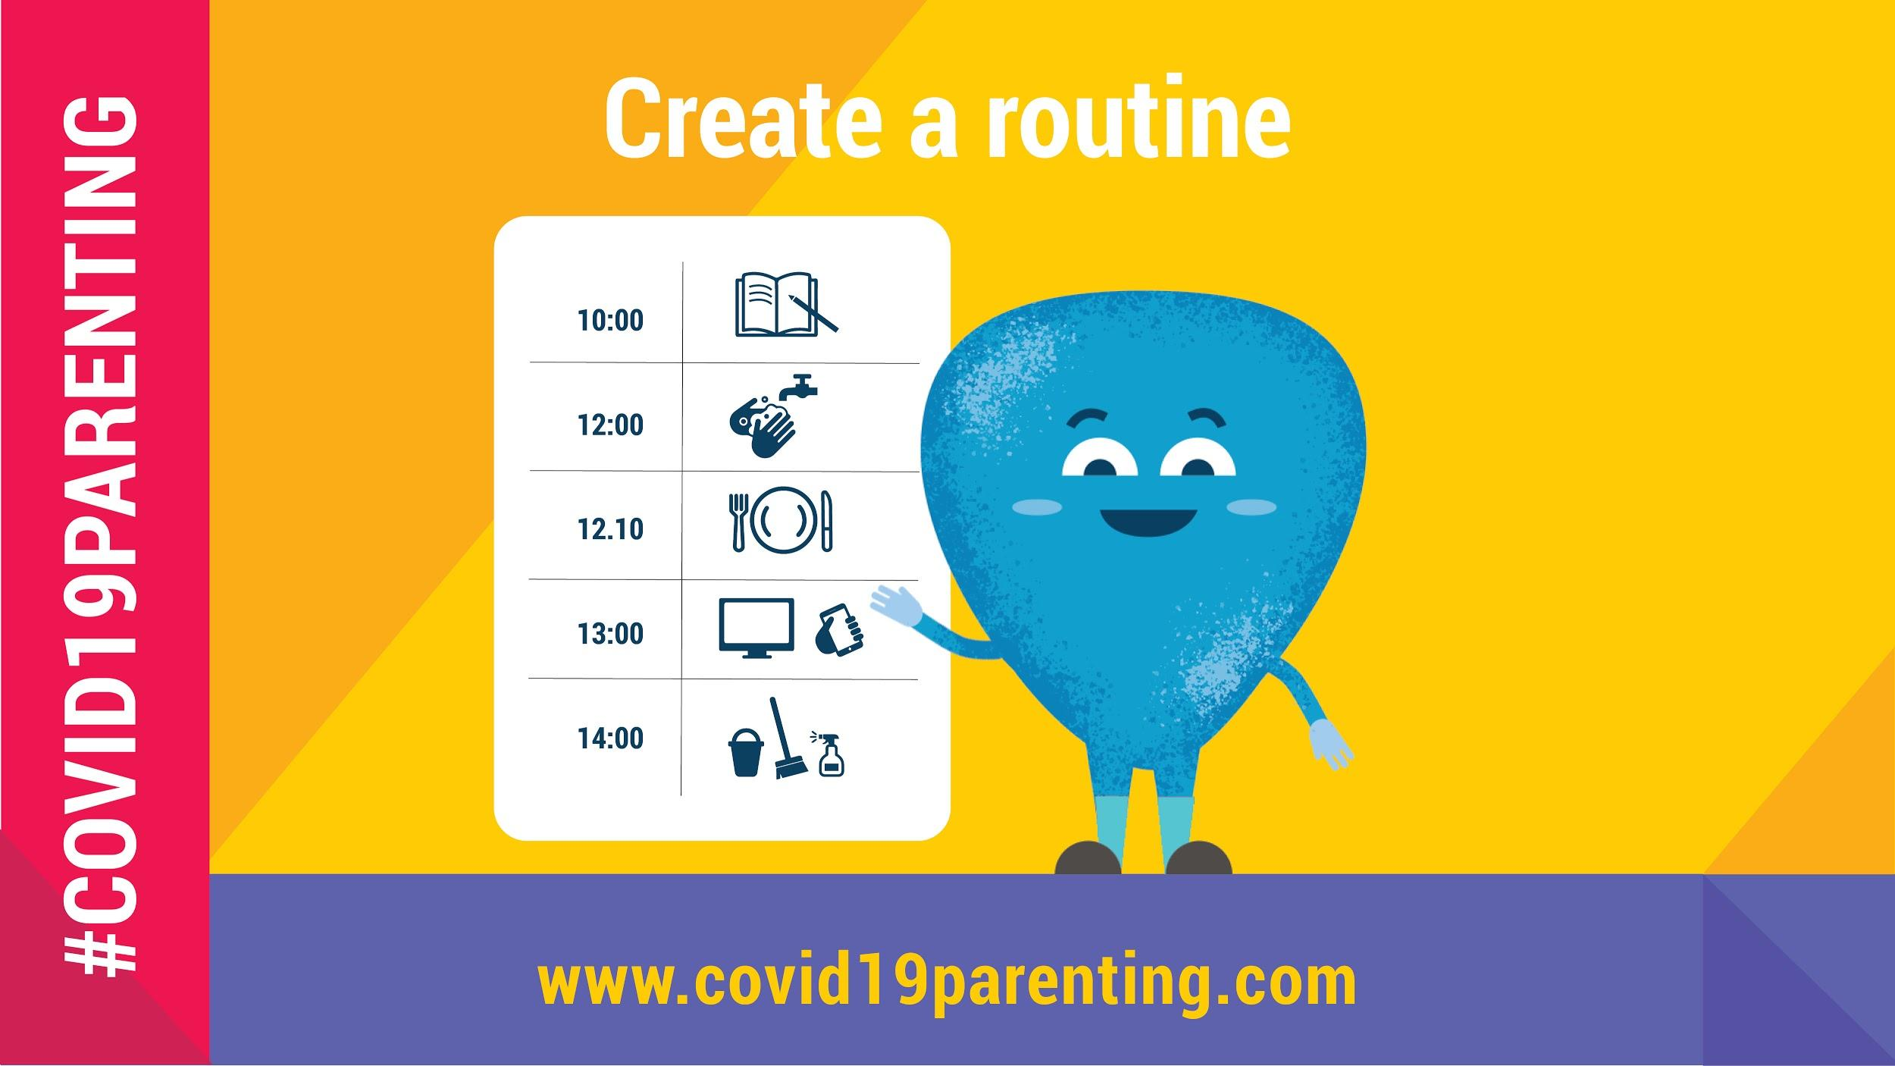 | Create a routine!  A structured day helps kids feel secure and makes it easier to manage them.  Try making a timetable with schoolwork, games, free time, exercise, and handwashing. Take charge of your days.  #COVID19Parenting tips: covid19parenting.com
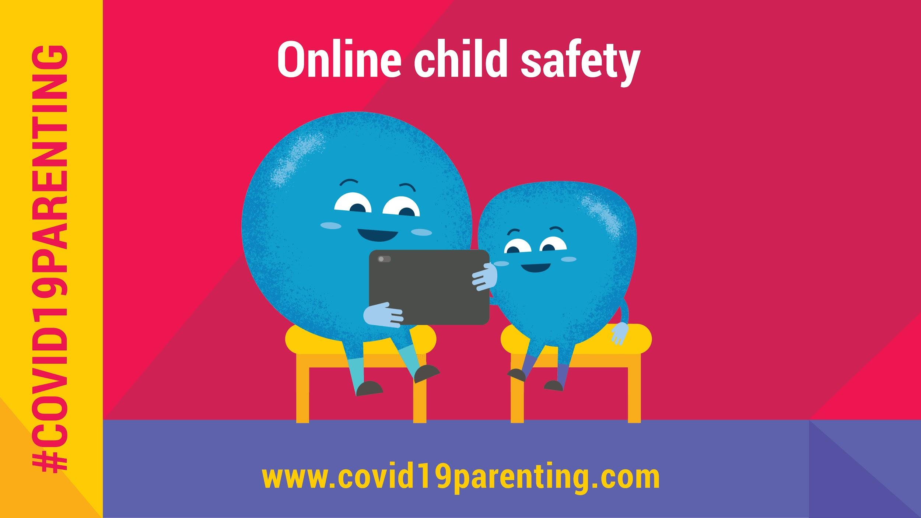 | Keep children safe online!  Children now spend a lot of time online. It helps them to be connected and cope with #COVID19 but it also presents risks. What are they? What tech fixes can you use to protect your children?  Check #COVID19Parenting tips: covid19parenting.com
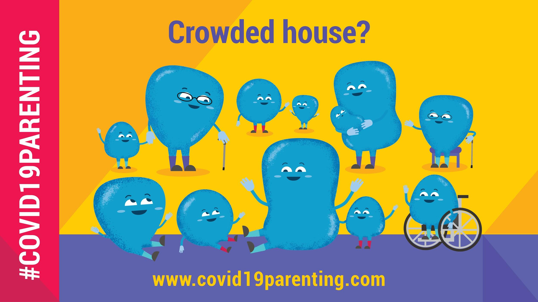 | Parenting in a crowded home?  It can feel even harder to keep your family healthy & safe from #COVID19. To make it easier, try to:  ➡️ Share the load  ➡️ Exercise daily  ➡️ Take a Pause  ➡️ Make social distancing & hygiene a fun routine  #COVID19Parenting tips: covid19parenting.com
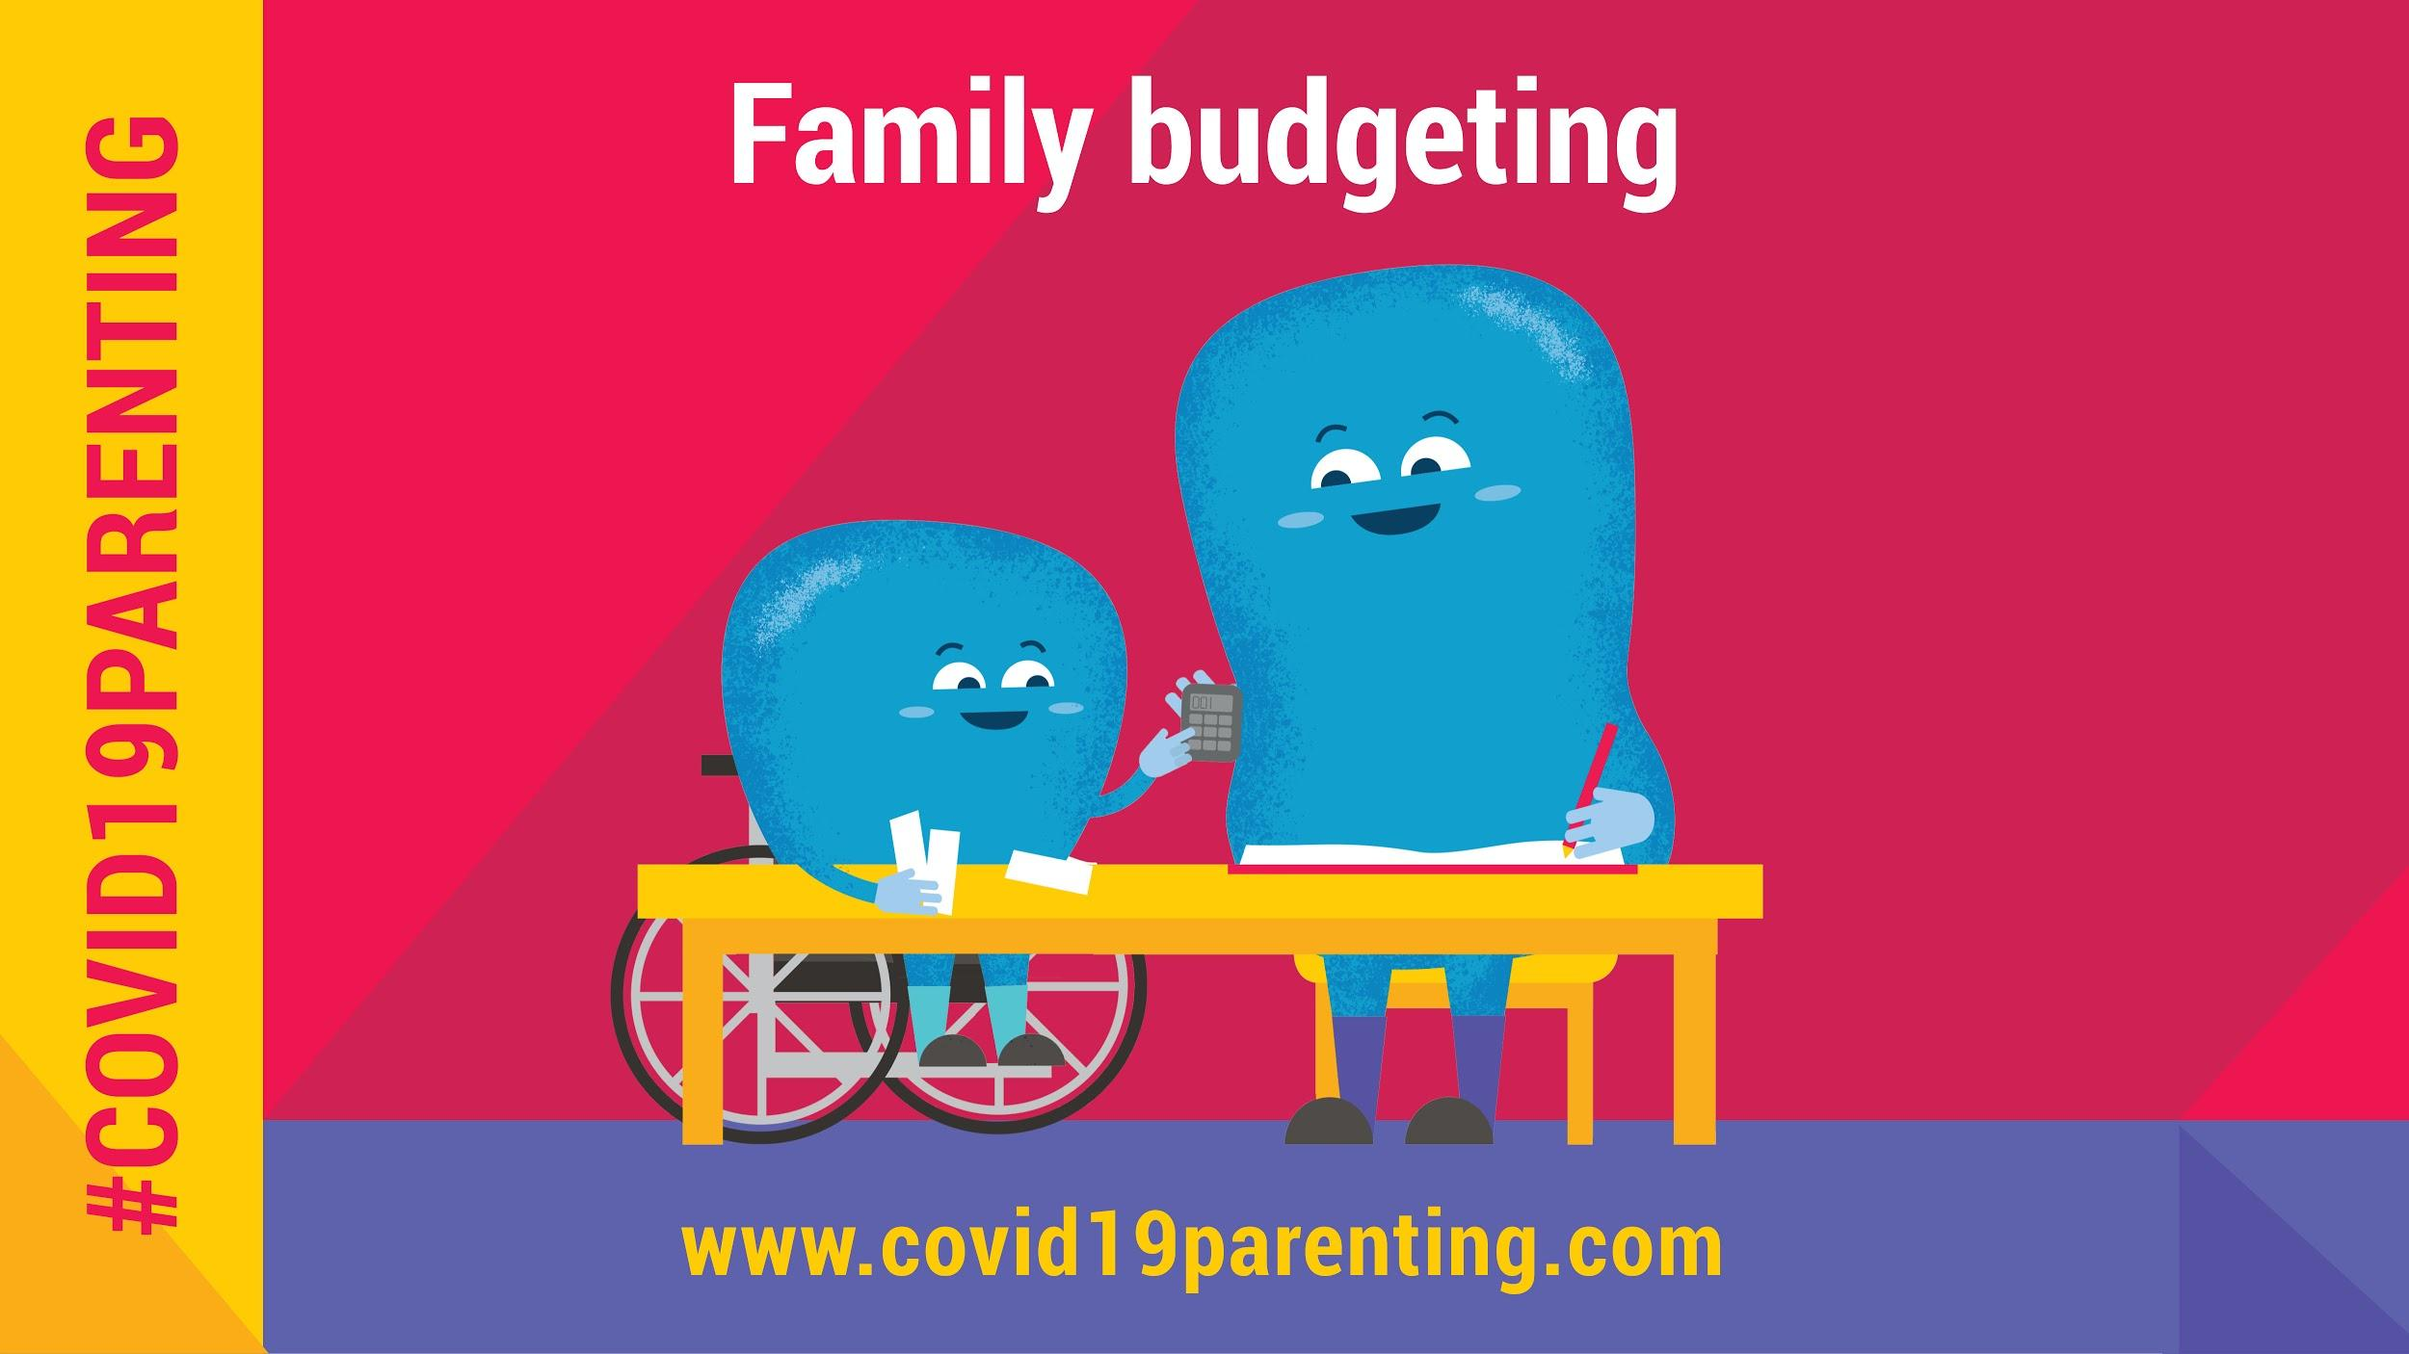 | Stressed about money because of #COVID19?  You are among the millions. Children asking for things can cause arguments, but this can help:  ➡️ Look for support  ➡️ Ask how much you spend  ➡️ Think about your needs & wants  ➡️ Make a family budget with kids  #COVID19Parenting tips: covid19parenting.com
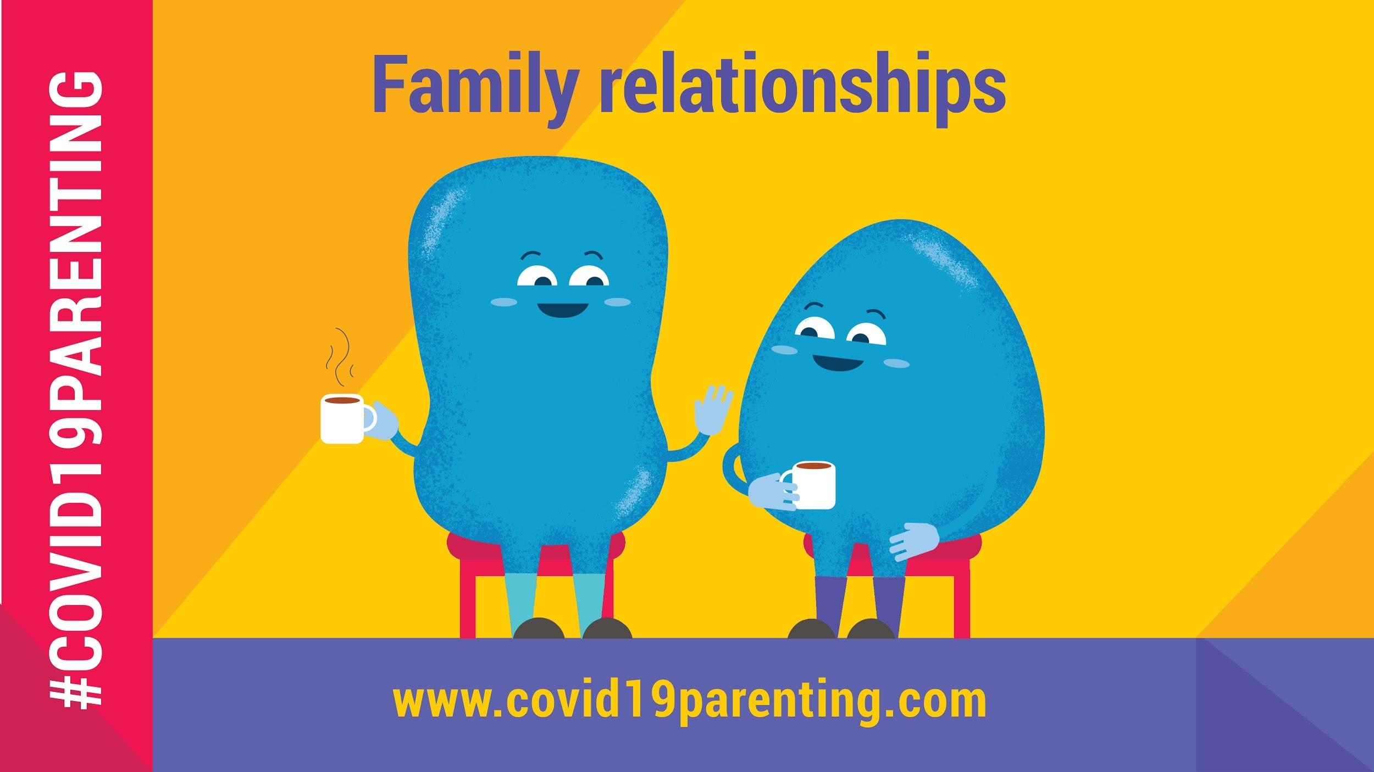 | Creating family harmony helps our children!  The more we practice modelling peaceful, loving relationships for our children the more secure and loved they will feel. Positive language, active listening and empathy will do magic 💫  #COVID19Parenting tips:  covid19parenting.com
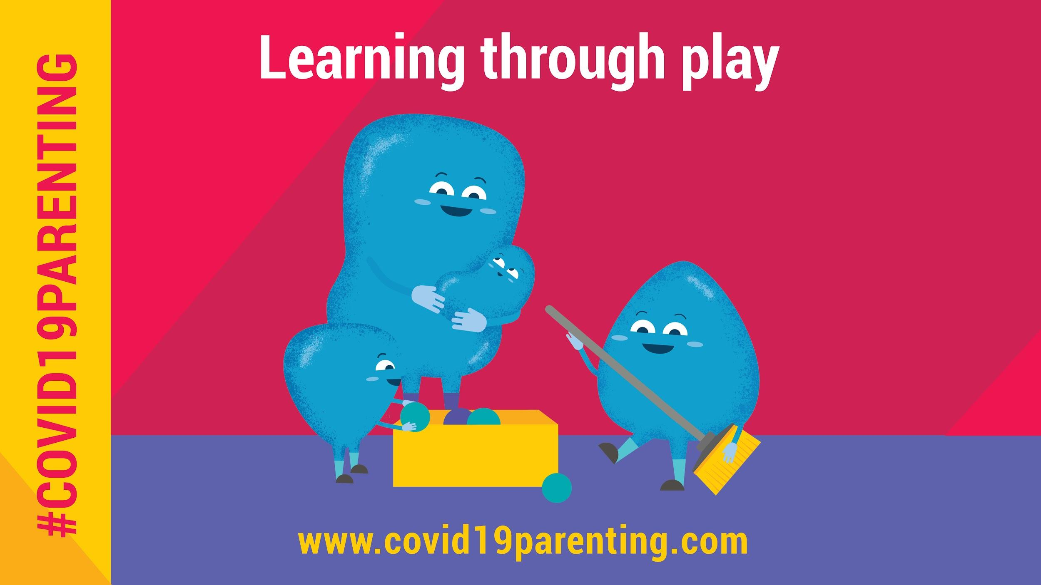 | Millions of children face school closure & isolation in their own home.  Have you tried learning through play? It can be both fun and educational for all ages! There are so many different types of games. See which one you like 👇  #COVID19Parenting tips: covid19parenting.com
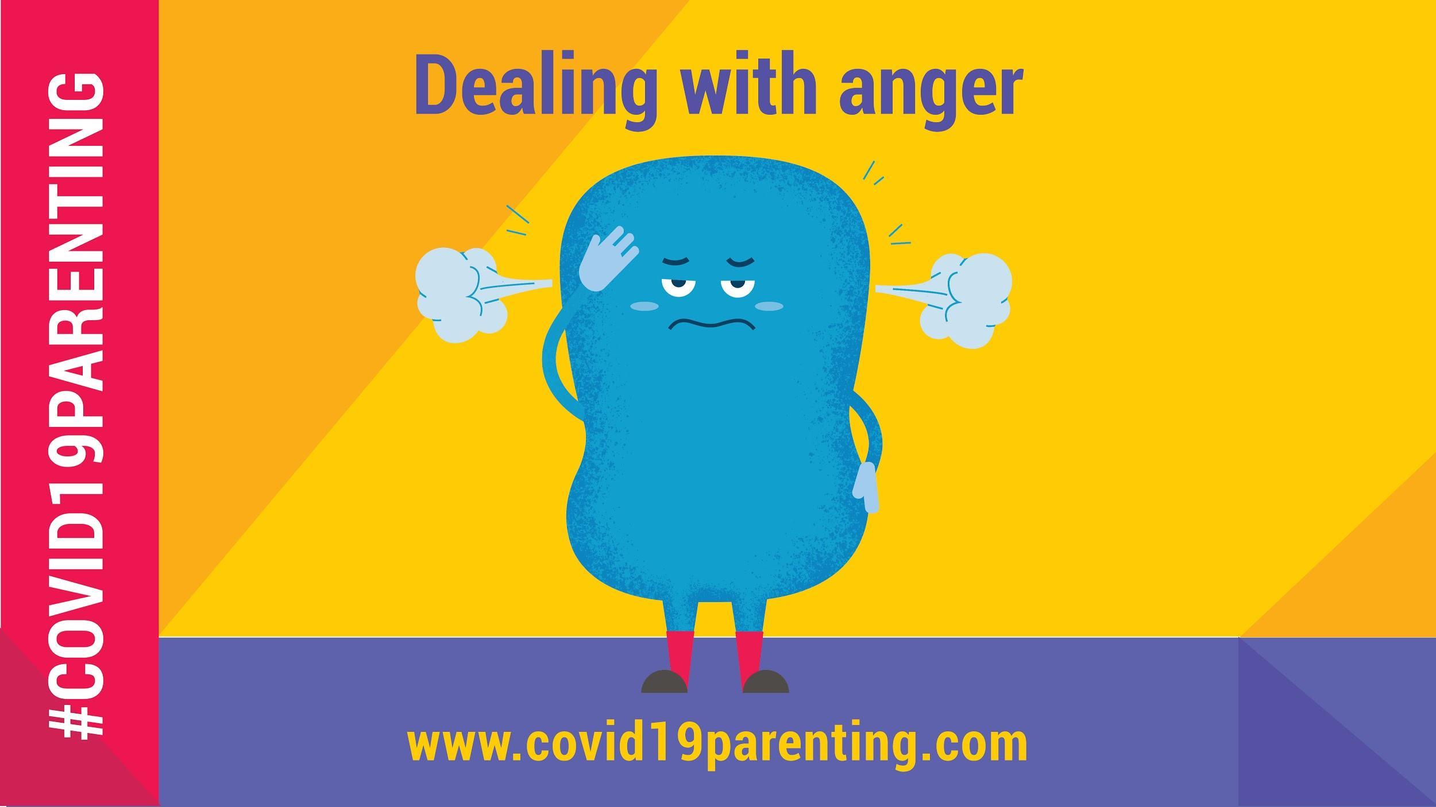 | When we get angry...  We love our children, but the stresses of #COVID19, money and lockdown can make us angry. Here are some tips on how to prevent it from happening and take control of your next steps ⬇️  #COVID19Parenting:  covid19parenting.com
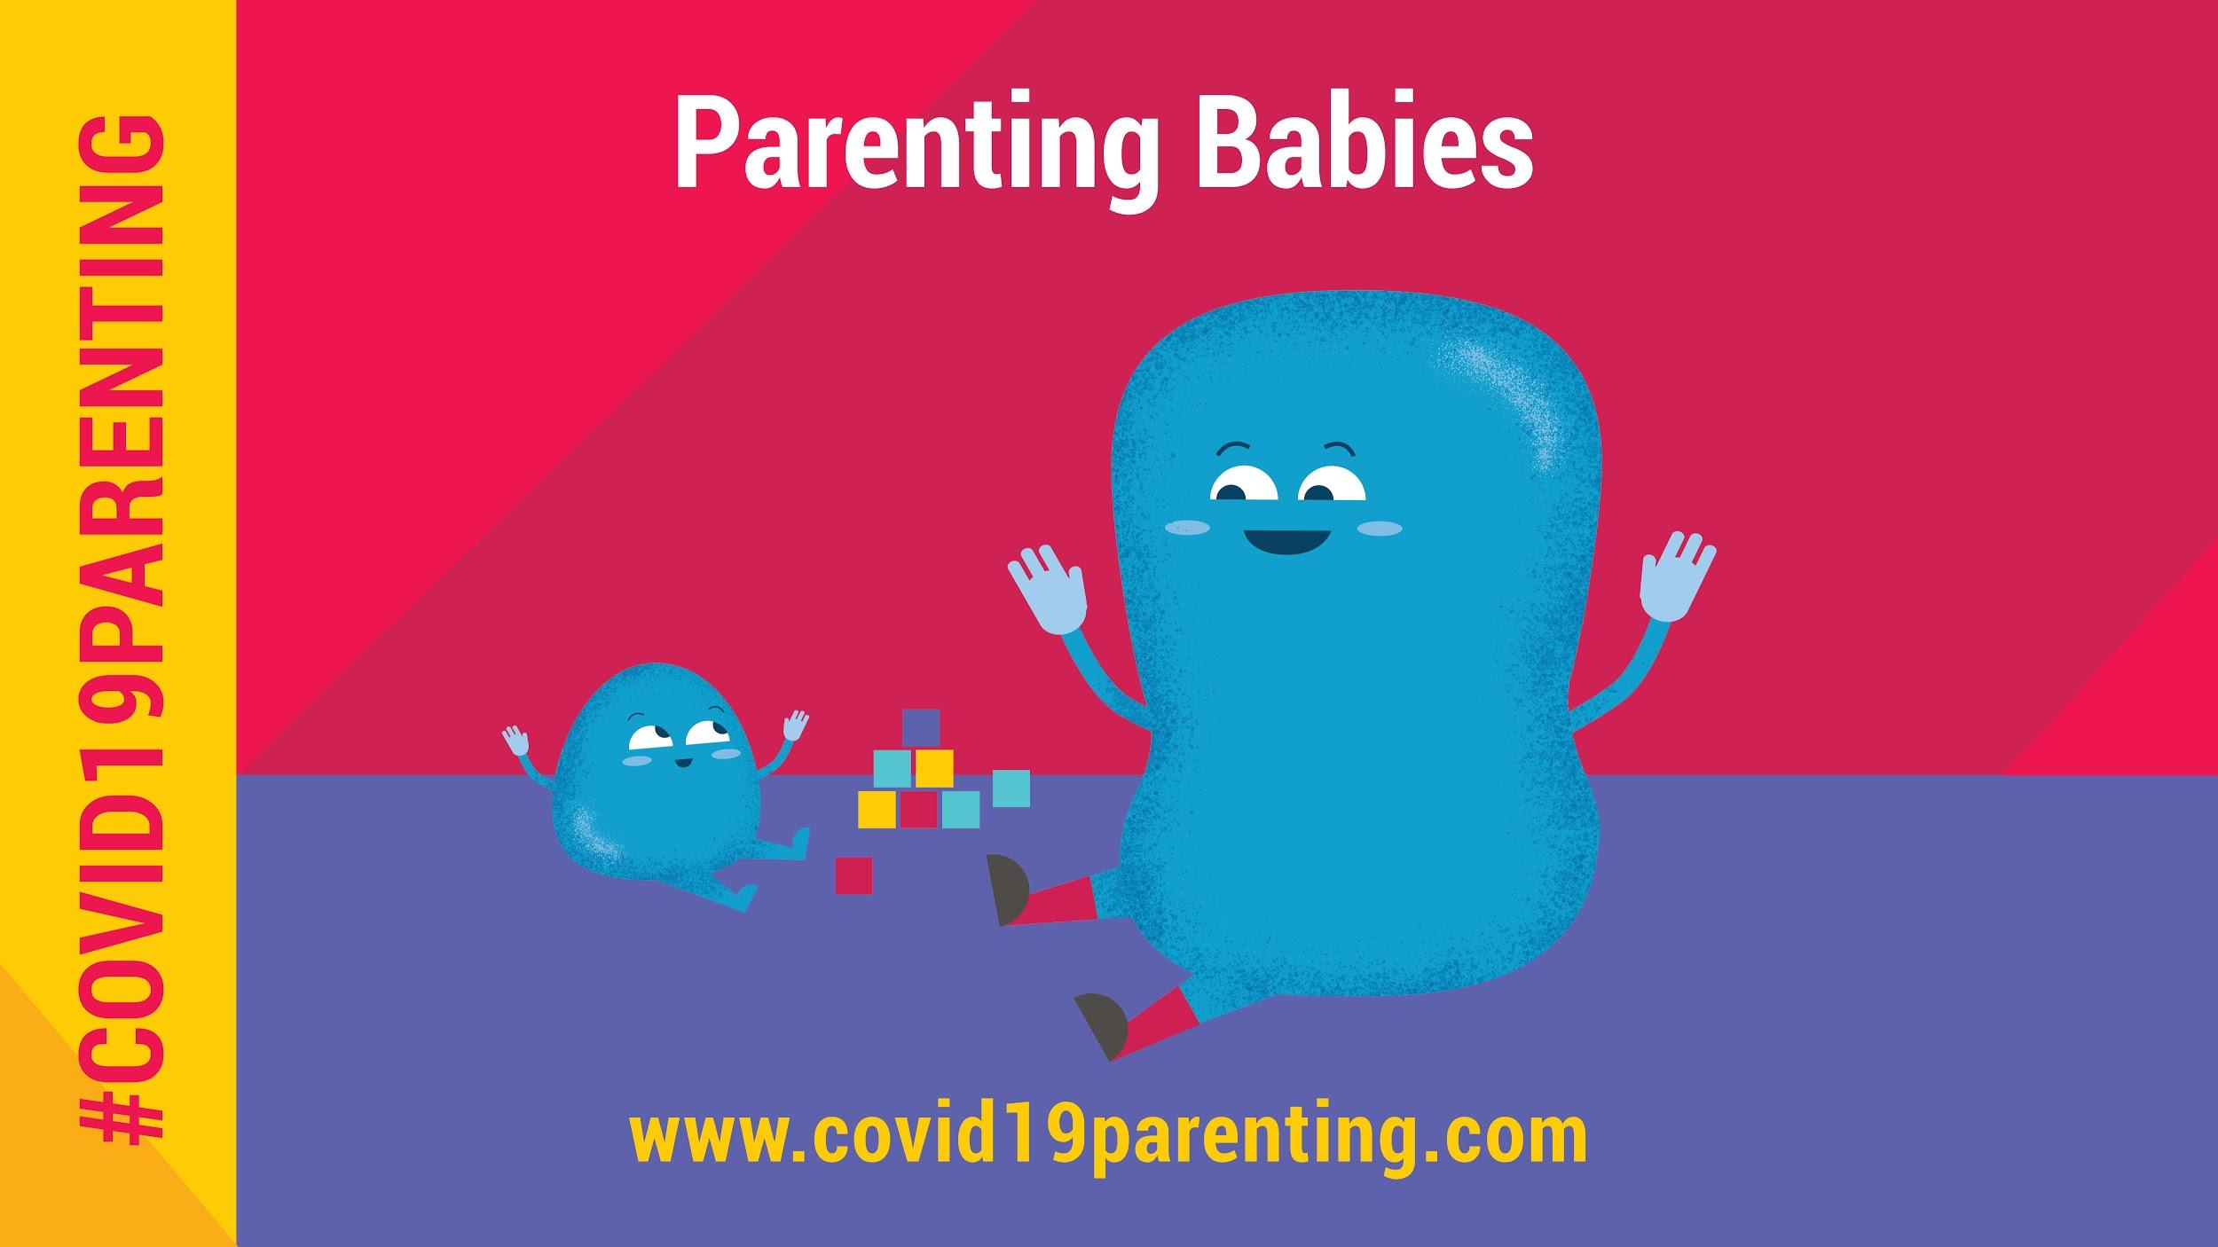 | Parenting a new baby is tough. The #COVID19 pandemic can make it especially challenging. You are not alone. These science-based resources can help you ⬇️  #COVID19Parenting tips:  covid19parenting.com  🎶 Sing songs  👄 Talk and tell stories  😝 Play games like peek-a-boo  😊 Manage stress  📱 Connect with loved ones
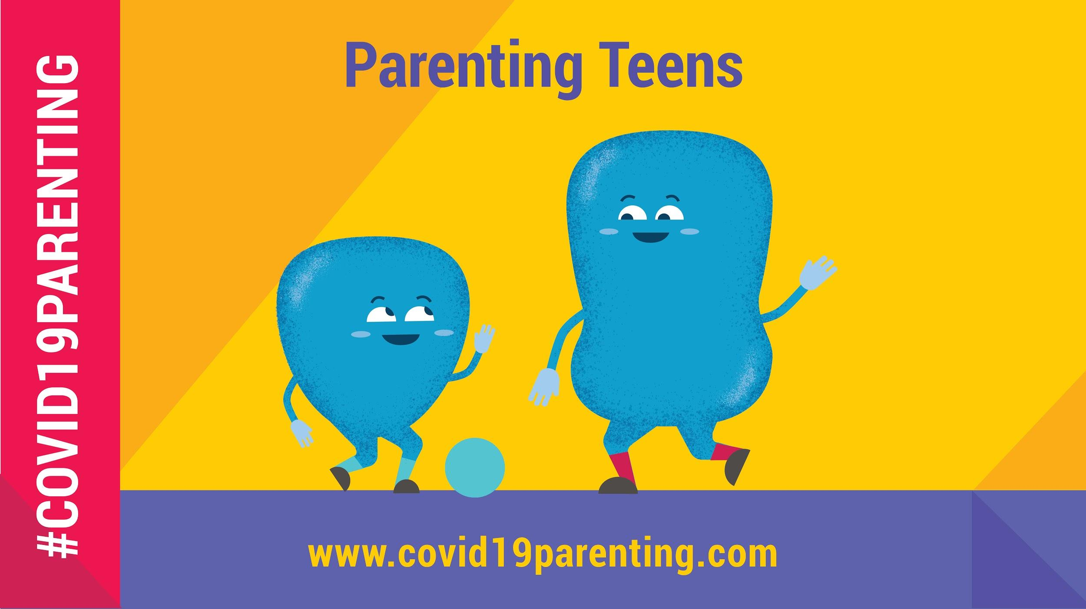 | Parenting teens has always been tough. #COVID19 just made it harder. These science-based resources explain how to support them ⬇️  #COVID19Parenting tips:  covid19parenting.com  🕒 Spend time together  🗓 Create routines  💕 Show kindness  😊 Manage stress  👄 Talk about challenging behaviour, feelings & COVID
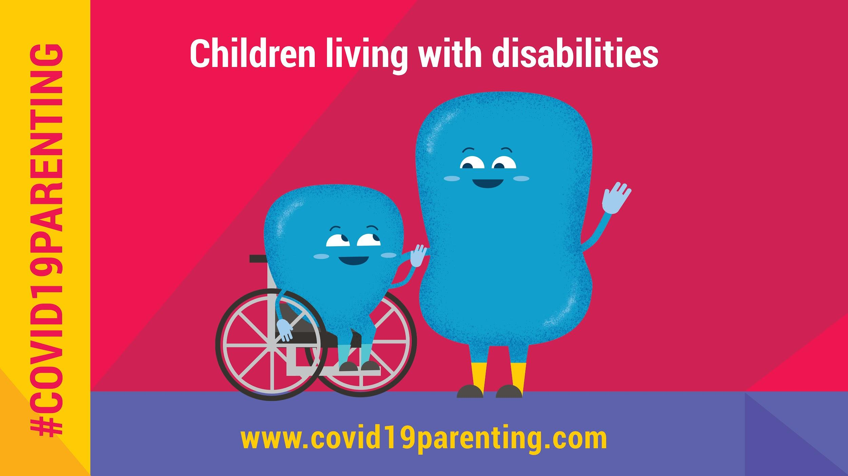 | Parents with disabilities & parents of children with disabilities are already under extreme stress, and #COVID19 can make it even harder to manage. You are not alone. These science-based resources can help ⬇️  #COVID19Parenting tips: covid19parenting.com  ✅ Manage stress  ✅ Create daily routines  ✅ Spend time one-on-one  ✅ Praise

